Digital Photography
Standard 8 quiz

- What compositional guideline is represented by a set of railroad tracks receding into the distance? (8.4)
- Framing
- Visual emphasis
- Perspective
- Leading Lines

- Which compositional guideline says to have a contrast of shape, color, texture, etc. to make subject stand out from background? (8.1)
- Framing
- Emphasis
- Rule of Thirds
- Perspective

- Which compositional guideline says to divide your photo into thirds vertically and horizontally and line your subject on one of these lines? (8.2)
- Framing
- Visual emphasis
- Rule of Thirds
- Perspective

- Which compositional guideline says to place the camera on the ground or high above the subject? (8.3)
- Framing
- Visual emphasis
- Perspective
- Rule of thirds
- Name this element of composition: (8:2)
  - Framing
  - Perspective
  - Visual emphasis
  - Leading lines
  - Rule of thirds

- Name this element of composition: (8:3)
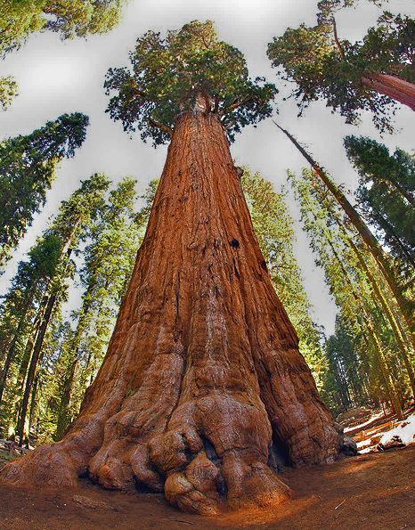
  - Framing
  - Perspective
  - Rule of thirds
  - Visual emphasis
  - Leading lines

- Name this element of composition: (8:1)
  - Framing
  - Perspective
  - Rule of thirds
  - Visual emphasis
  - Leading lines

- Name this element of composition: (8:4)
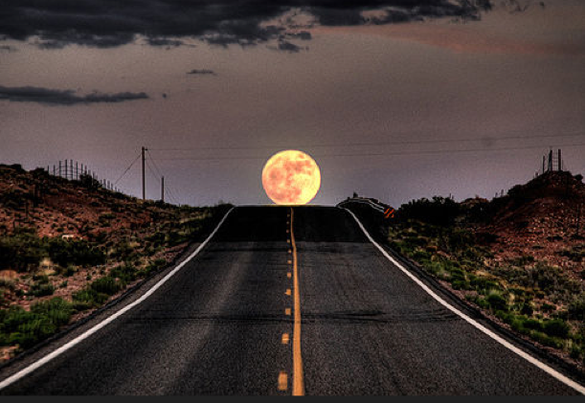
  - Framing
  - Perspective
  - Rule of thirds
  - Visual emphasis
  - Leading lines

- Name this element of composition: (8)
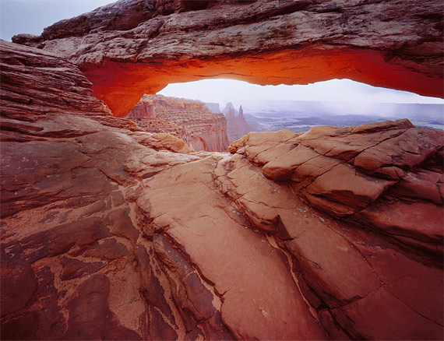
  - Framing
  - Perspective
  - Rule of thirds
  - Visual emphasis
  - Leading lines

