Digital Photography
Standard 7 quiz

- What key on the keyboard do you press to add to a selection in Photoshop? (7:10)
  - P
  - A
  - Option/alt
  - Shift

- What Photoshop icon will show/hide a layer? (7:6)
  - Eyeball
  - Magnifying Glass
  - Magic Wand
  - Brush

- What is the keyboard shortcut if you want to increase or decrease the brush size of Photoshop tools? (7.5)
  - Bracket keys [ ]
  - Shift key
  - Ctrl + 1
  - Ctrl + A

- The tool in Photoshop that makes a multi-sided straight sided selections is called the: (7.10)
  - Magnetic Lasso tool
  - Polygonal Lasso Tool
  - Spot healing Brush
  - Magic Wand tool

- What tool in Photoshop allows you to choose a color from an image so it is the foreground color that you can use with the text, tool, brush tool, etc? (7.5)
  - Lasso
  - Gradient
  - Magic Wand
  - Eyedropper

- Beside the Spot Healing Brush tool in Photoshop what is another tool that can be used for blemish repair? (7:5)
  - Burn Tool
  - Bracket Keys
  - Clone Stamp Tool
  - Dodge Tool

- What is the feature in Photoshop that allows you to have multiple modifiable elements stacked on top of one another? (7:6)
  - Layers
  - Transform
  - Histogram
  - Crop

- What resolution is best for posting your images on the Internet? (7:1)
  - 72 ppi
  - 100 ppi
  - 120 ppi
  - 300 ppi

- What do you call it when you convert a color image into a black and white image? (7:7)
  - Color correction
  - Desaturation
  - Exposure
  - Levels adjustment

- Which tool would you use if you wanted to rotate an image? (7:9)
  - Move tool
  - Hand tool
  - Crop tool
  - Transform tool

- When you create a new layer in photoshop, where does it go? (7:6)
  - Above active layer
  - Below active layer
  - At the top of all layers
  - At the bottom of all layers

- What feature allows you to take multiple steps back in photoshop? (7:8)
  - Layers
  - Channels
  - History
  - Selections

- What photoshop tool lightens? (7.2)
  - Magic wand
  - Clone stamp
  - Dodge
  - Burn

- What photoshop tool darkens? (7.2)
  - Magic wand
  - Clone stamp
  - Dodge
  - Burn

- What is the most common photo file type? (7.11)
  - PNG
  - MOV
  - JPEG
  - PSD

- What type of file is a psd? (7.11)
  - Image file
  - Photoshop file
  - Illustrator file
  - Movie file

- Which of these tools allows you to designate a specific color from your image as the foreground color in Photoshop? (7:5)

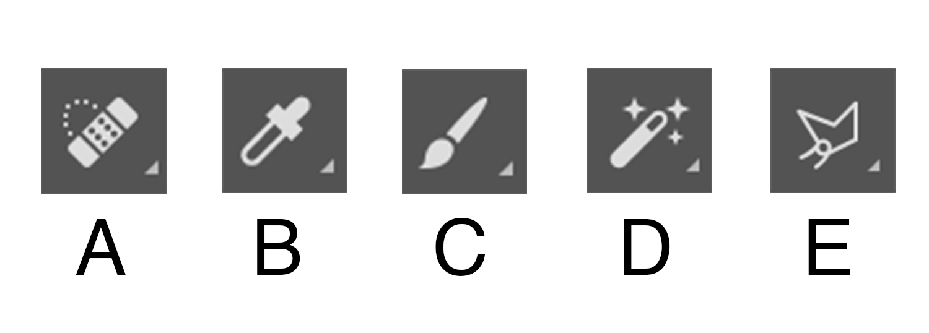

18. Which of these tools is the cropping tool and can be used to change height, width and resolution (7.1)

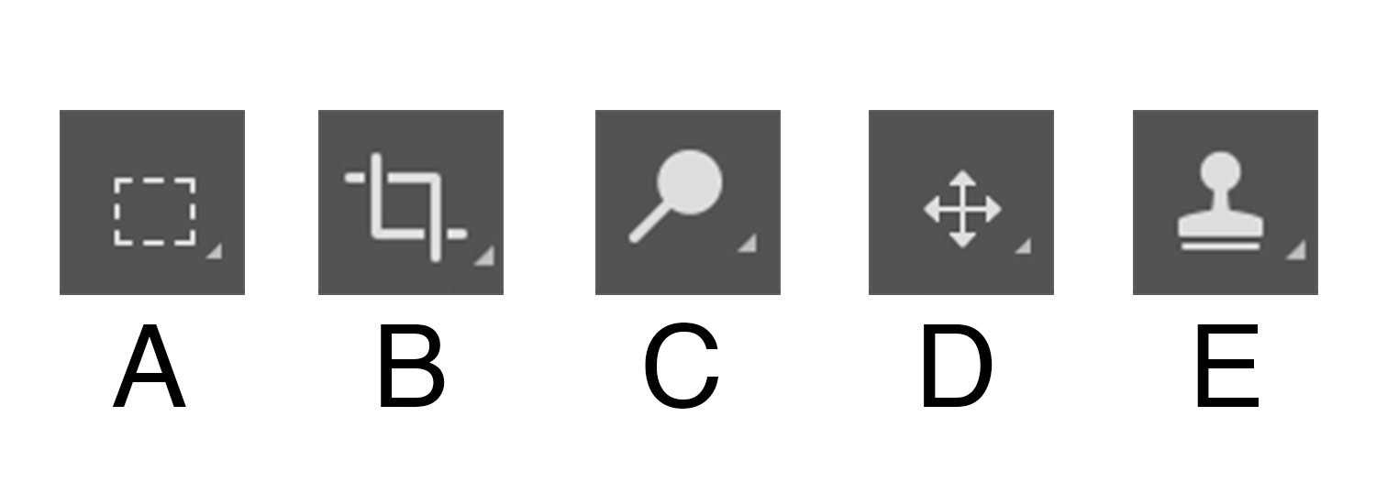

19. Which of these tools is the clone stamp? (7.5)

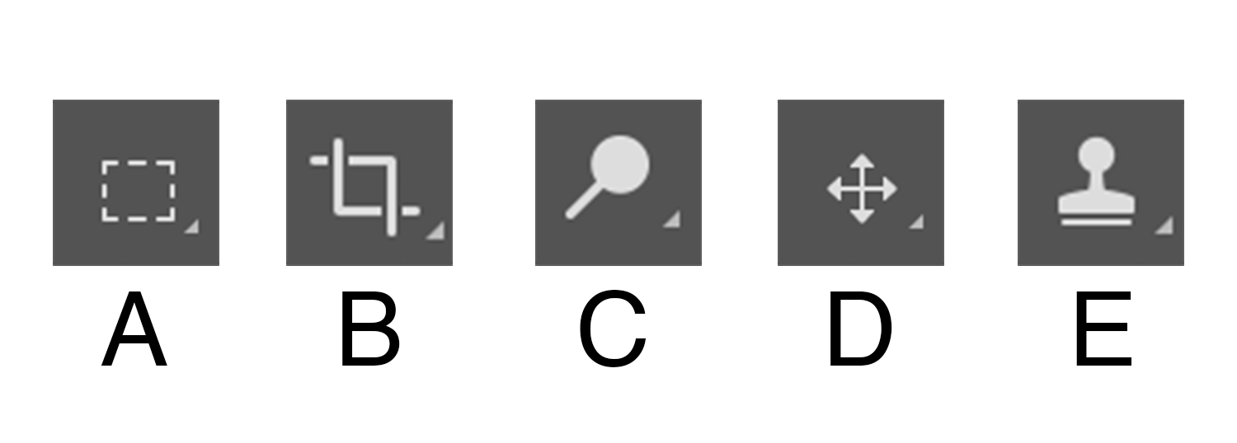

20. In Photoshop which of these tools allows you to select pixels of similar colors within your image? (7.10)

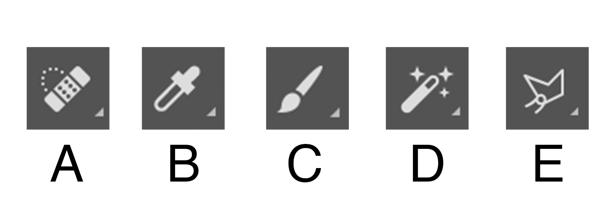

21. What does an layer look like at 50% opacity? (7.6)
- It is completely transparent
- It’s half transparent
- It’s not transparent
- It is darkened

