Digital Photography
Standard 5 quiz

1.What is the most common type of memory card used in digital photography? (5:4)
- Compact Flash card
- Internal Storage card
- Memory Stick
- Secure Digital card

2. Identify the most common resolution needed for capturing images for print. (5:3)
- Basic/Medium/180ppi
- Fine/Large/300ppi
- Normal/Small/72ppi
- Extra Fine/High/RAW

3. A memory card reader is used to (5:5)
- Transfer images from the camera to the computer
- Tell the camera’s future
- Transfer images from the memory card to the computer
- Send the digital information from the sensor to the memory card

4. When you see the individual elements or squares of color that make up a digital image it is called (5:3)
- Automation
- Pixelization
- Animation
- Granulation

5. Which of the following is a CF card? (5:4)
A. B. C. D
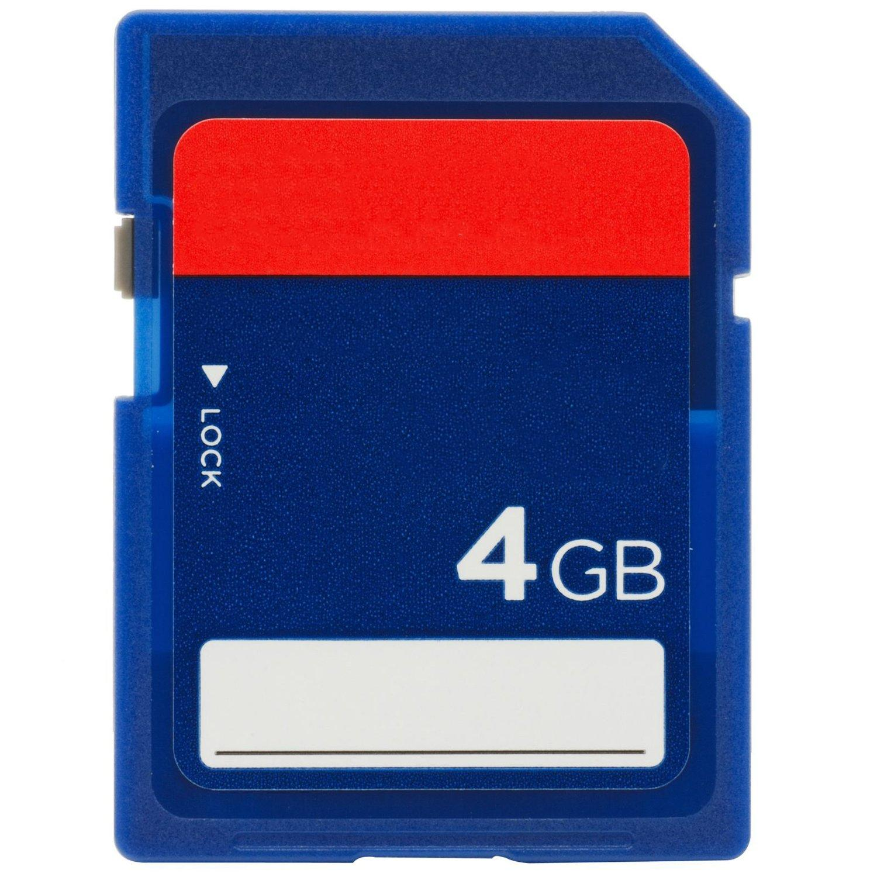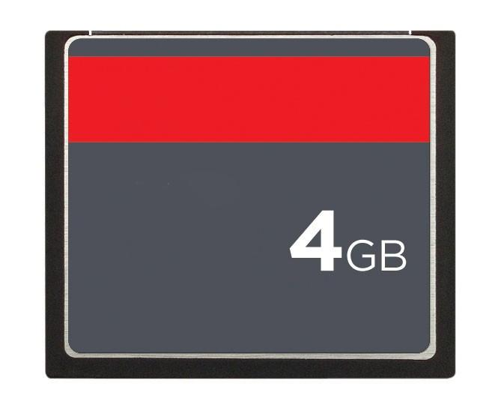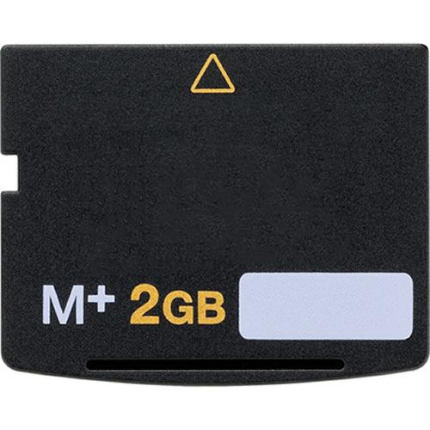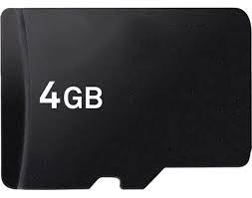

6. Which of the following is an SD card? (5:4)

A. B. C. D

7. Which of the following is a Micro-SD card? (5:4)

A. B. C. D

8. Which of the following is an XD memory card? (5:4)

A. B. C. D

