Digital Photography
Standard 3 quiz

1.Which of these image capture devices is a DSLR? (3:3)

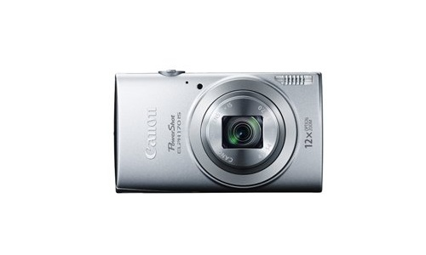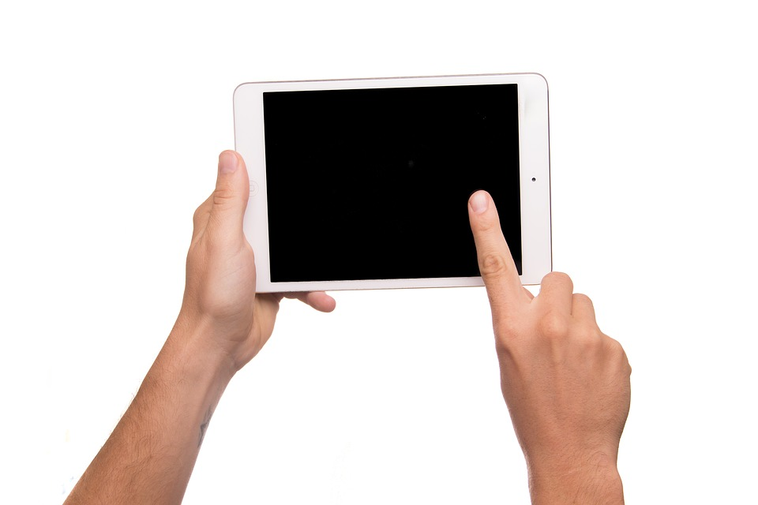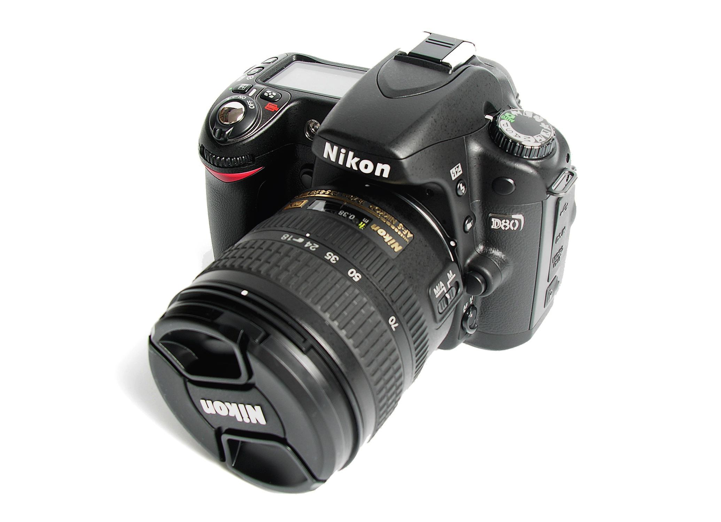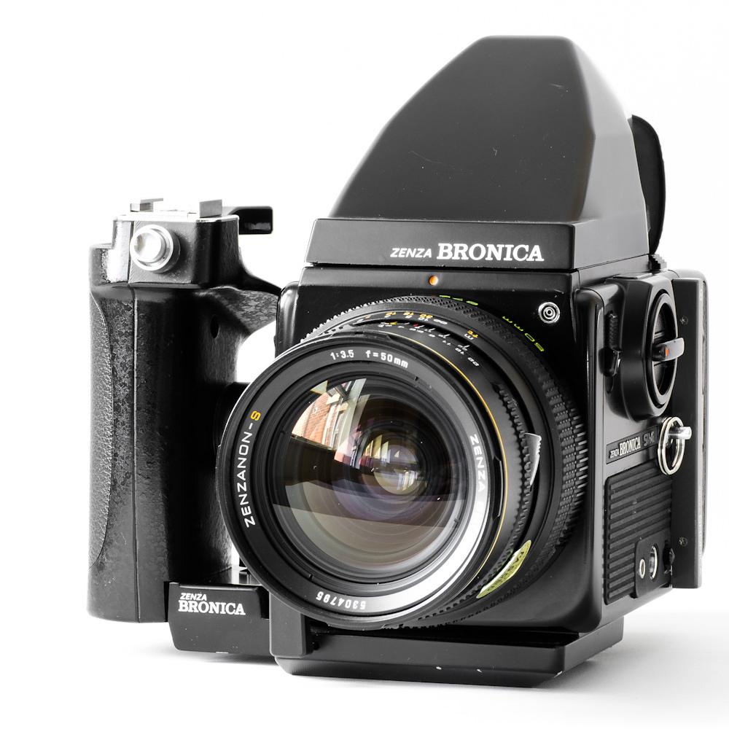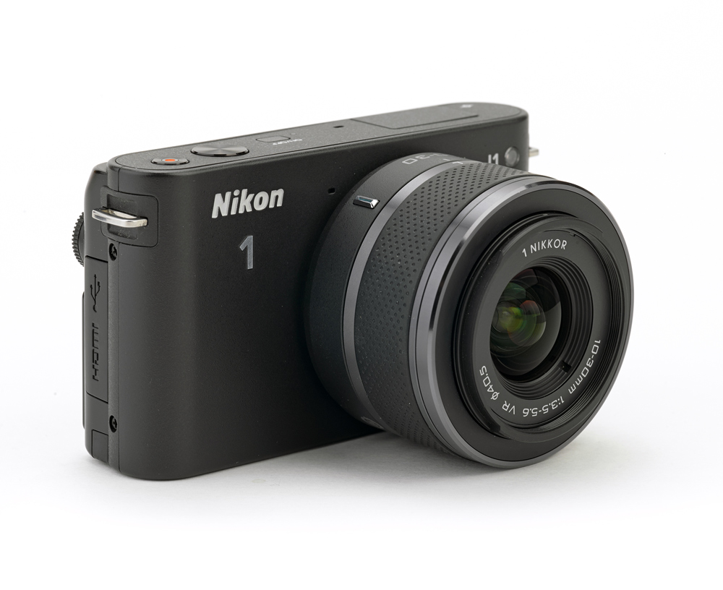
A B. C. D. E.

2. Which of these image capture devices is a point and shoot? (3:2)

A B. C. D. E.

3. Which of these image capture devices is a mirrorless interchangeable lens camera? (3:4)

A B. C. D. E.

4. What does SLR stand for? (3:1)
- Silly Little Redheads
- Slim Lens Recorder
- Single Light Recorded
- Single Lens Reflex

5. What camera would be ideal for shooting a wedding? (3:1)
- GoPro
- SLR
- Point and Shoot
- Phone

6. What camera allows for interchangeable lenses? (3:1)
- GoPro
- Point and shoot
- SLR
- Phone

7. What camera would be best for a hiking trip? (3:1)
- Medium Format
- Point and Shoot
- Twin Lens Reflex
- Single Lens Reflex

8. What makes a mirrorless camera different than an SLR? (3:4)
- The camera does not contain a mirror
- The camera contains a mirror
- Photographs are recorded using a flux capacitor.
- Photographs are recorded using a sensor.

9. Which of the following types of cameras will not allow you to digital zoom? (3.3)
- DSLR
- Twin Lens Reflex
- Point & shoot
- Cell phone

